Operating System Week 8-9

Name : Tanishq Vyas
SRN : PES1201800125
Section : H
Semester : 5
Branch : CSE

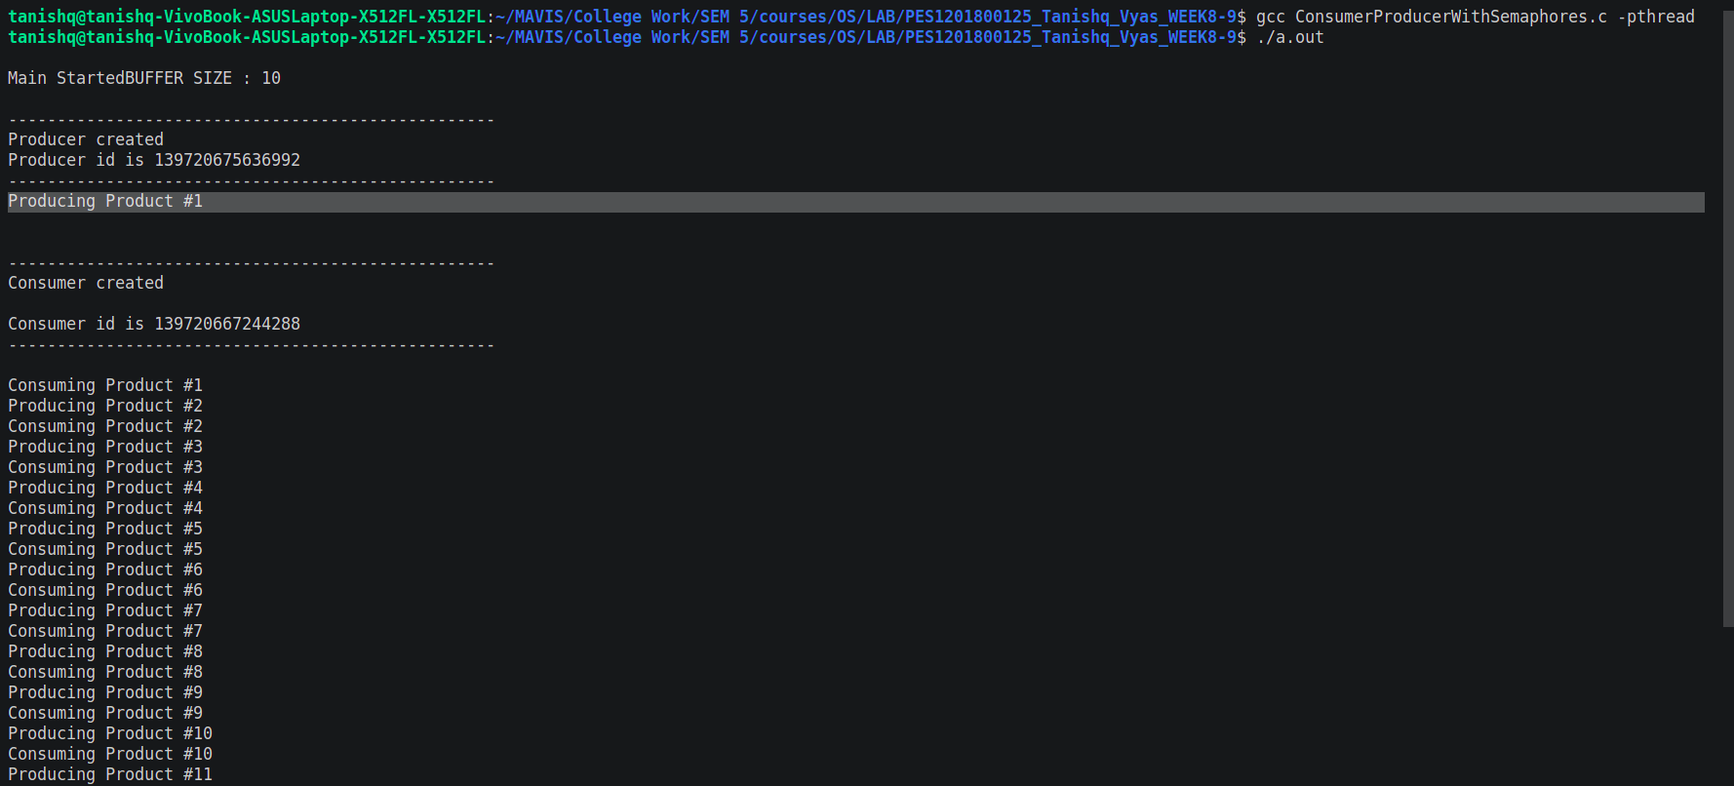
Fig : Execution for Producer-Consumer with Semaphore
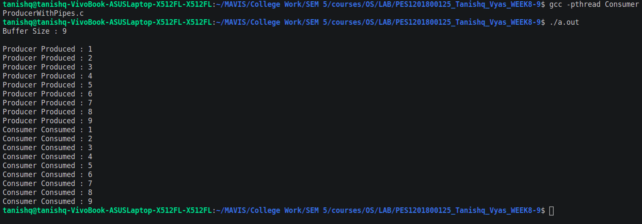

Fig : Execution for Producer-Consumer with Pipes

